American Populism & Leadership in 2024?
By Paul Mourino
Huz-zah…Huz-zah…! The coming 2024 Presidential Election marks a turning point in American History, and beyond, there lies a series of major demographic, economic, and political forks in road. These historic choices all beg the question; what will the future bring? The American Citizen must decide on a very specific set of policy choices and a limited array of qualified political leaders to enable such policies to either renew our constitutional republic or lead us further down the road to empire or totalitarian state-oligarchism. Presently, these political leaders championing a return to a constitutional republic fashion themselves as populists and tend to be on the right, or conservative, side of the political spectrum; but populism can come from either the left or the right side of the political spectrum.
But what is populism? Populism properly defined is a broad appeal to “a range of political stances that emphasize the idea of "the people" and often juxtaposes this group against "the elite" and is frequently associated with anti-establishment and anti-political sentiment.” In 2016, the United States was inspired by the Leadership and populist appeal of Donald Trump; his rhetorical appeals to traditional American values of “faith, freedom, and family” were very successful but his implementation, during his Presidency 2016 -2020, was only partially successful. This trial by fire, has shown, to those who care to be paying attention to the details, that there are powerful interests arrayed against the application of any set of populist policy remedies. Therefore, we must ask, will a populist leadership be successful to inspire and lead the American Citizenry through these difficult times ahead? In short will a, ‘Made in America’ populist political movement be able to manifest, “Make American Great Again?” in 2024 and beyond?
The last year of politics, 2022-2023, has demonstrated that an American populist appeal will get us to the door of change, but it has not yet demonstrated the ability to create the lasting changes required to clean up and answer all the demographic, economic, and political challenges which lie before us. Take for example, the much anticipated ‘Red Republican Wave,” which was expected in November 2022 midterm election. Many of the best populist political leaders, on the conservative right, were not elected and the populists Republicans who were elected to the US Congress were only able to gain a small margin over the Democrats in the US House of Representatives; which equates to 1 small leadership faction in a portion, of a third, of the Federal Government. The Democrats still hold the Senate and the Presidency while the Judiciary seems to be watching passively on the question of electoral integrity issues. Now to the present, that small group of committed populist-conservative Republican Congressman forced the Republican Leadership to bend to a modest set of conservative policy demands during House Speaker Kevin McCarthy’s vote for the House Speakership, and now that victory seems to have been blunted, or betrayed, by speaker McCarthy’s deal with President Biden and centrists’ interests, in both the Republican and Democratic party. Just look at the vote, count the ‘yeahs’ and ‘neighs’ for the proposed budget bill to increase the debt ceiling. In New York’s Republican Congressional Caucus, all of them voted for the bill, while NY’s left leaning Congressional Democrats voted “neigh”. About a dozen conservative-populist Republicans also votes neigh, to propel this debate into the coming days/weeks ahead. The interests who voted yeah, voted to pass a new debt ceiling limit which increases the budget over the next 2 years. Concordantly, now 2 weeks later, 20 some republicans join the Democrats in opposition to Congresswoman Anna Paulina Luna, H. Res. 489 bill to censure and fine Congressman Adam Schiff. Sadly, none of the major policy complaints by the populists were addressed and, in effect, the deal to extend the debt limit over the next 2 years, potentially blunts the leverage of a mobilized populist leadership and citizenry who might determine the election of the next President. This observation, leads one to be very pessimistic for the future of such populist appeals.
Fear not, this story is not over until it’s over; and the Biden Regime’s continued legal persecution of former President Donald Trump is propelling former President Donald Trump into front runner status and all but guarantees him the nomination for the Republican Party’s Nomination for President in 2024. As we continue to build and recruit new leaders into this battle, the populists appeal must be seasoned, tempered, and enhanced by expert level skills from all disciplines, and topped off with the proper amount of substance, boldness, and immunity to the slings and arrows of outrageous fortune. Looking Across the aisle, the populist left is being mobilized by Robert F. Kennedy Jr. whose Presidential campaign is gaining a great deal of support, much to the chagrin of the establishment. Even though he enjoys no support from the main stream media, his campaign enjoys 20 % support from the Democratic side of the isle. Additionally, RFK Jr.’s unique family history, subject matter expert knowledge on the environmental law and vaccines, is a helpful assist to the unique remedy needed in our political catharsis coming in 2024.
If this fight this sounds impossible, kindly remember this is the story of how these United States were built. Any successful populist leader today, must know and live this history, know how this nation was built, and be able to eloquently reacquaint the masses to these time-honored battles for our republic. It’s the only way to overcome the limits of the present to build a prosperous future. Lastly, this populist leadership must be tempered by stoic like immunity to the temptations of money and power. Historically speaking this experience has been called the “American System of Political Economy,” and we who choose to lead in the present must know this story inside and out and manifest the courage to charge forward with its banner. Long Live the Republic.
American Stoic vs Global American Empire
Will the average American Citizen be able to reset/adjust, the institutions of American Power to be in line with America’s National interest or the American system of political economic? Pound for pound, the individual citizen has infinitely, small powers and very weak influences relative to the combined financial-economic might of the numerous Federal Agencies, think-tanks, Media Outlets, and Third-Party Federal Government Suppliers which are all mostly opposed to this idea. On the topics of war, peace, financial transparency, and public health the individual citizen’s power to vote dwarfs the summary interests arrayed against him/her unless that vote is directed to a qualified leadership. Just look at the recent record. Regarding the deployment of war powers: War in Afghanistan 2001, War in Iraq 2003, War in Lybia 2008, War in Sudan 2009. The might and voting power of the military-media industrial complex beat the American Voting citizen each time with the exception of Trump’s Presidential election in 2016. How about the topic of financial accountability and oversight? President Bill Clinton, assisted by establishment Democrats & Republicans in 1999/2000, all successfully repealed the Banking Act of 1933, aka the Glass Stegall Act, thus paving the way for massive conflicts of interest between investment and commercial banking; which ultimately led the United State going into the 2008 financial collapse. The laws were changed, and since everyone agreed to participate, no one was guilty nor held responsible. Adding fuel to the fire, President Obama over saw a full-scale reorganization, and bailout, of all the concerned interests, and it was intentional. Obama’s plan was something he learned at Columbia University, from Dr. Howard and Dr. Cliven. Simply put, the Howard-Cliven Plan summarized, ‘kill capitalism by overwhelming the US economic system with debt and dependency,’ via government run welfare programs. Therefore, since 2008 thru to the present, the active circulating supply of money and debt has ballooned from around 1 trillion to approximately 40 trillion dollars.
On the topic of public health, the US has closed down all public health hospitals, and privatized or monopolized everything into large hospital systems which are ultimately run by the pharmaceutical industry and the Federal Government’s regulatory machine. The Hill Burton standard of health has been replaced by monopoly, profit motive, and institutional capture by pharmaceutical companies like Pfizer. Our national response to Covid 19, in 2020-22, demonstrates the depth of the negligence and corruption. Again, the individual citizen was forced to suffer the vested interests of Anthony Faucie’s public health empire, which has now proven to be utterly incompetent and malevolent. “Get the jab,” or no job for you. The supposed cure, Pfizer’s or Moderna’s experimental ‘vaccine’, causes more harm than health benefit. If therefor, the known universe is willing to bailout the United States indefinitely, from its many tragic errors, one must ask, or how long can, or should, this continue?
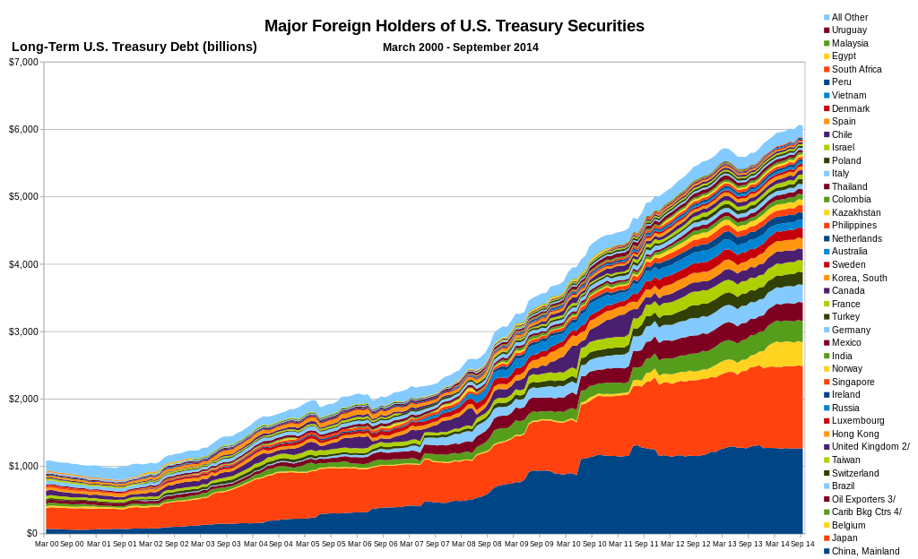
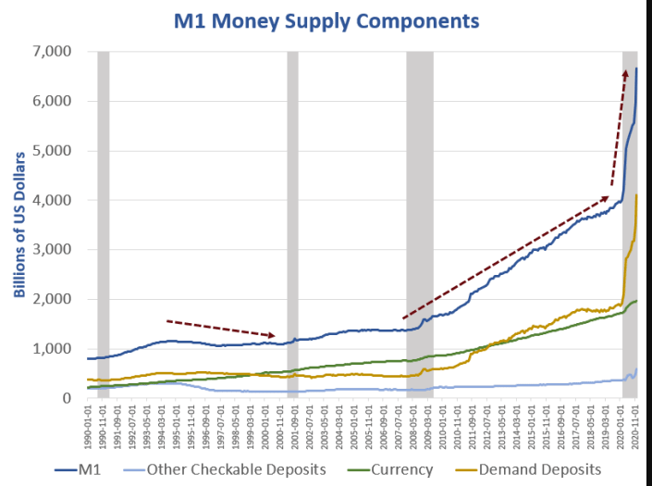

The American Citizen must ask what role can, or should, I play in the unfolding of this drama? What talents, philosophies, or contributions can I make towards this comedy of universally tragic errors? Some of us will vote, others will volunteer, and others still will try to lead our embattled republic thru this mess. Will we know who to choose to lead, and do those leaders recognize the difference between virtue & vice? We must hold our leaders, and ourselves, to a much stricter account, and a criterion of demonstrable knowledge, ability, and proven experiences. In short, our next band of populist leaders will be vetted by this horrific reality; and their ability to recognize these tragic errors summarized earlier, and champion the needed solutions come hell or high water.
Plato’s warnings from his “Republic,” is most instructive here. Politics is the only profession where a know nothing, of a person, can excel, accomplishing great success; because they can both appear to be and not be both the same thing and its opposite at the same time. New York’s recent voting experience teaches this…whether its George Santos on the Republican side or AOC (Alexandria Ocasio Cortez) on the Democrat side, politics attracts very strange actors. Plato succinctly described these actors as sophists, and the only true aim of the sophist is to attain power, money, glory, and fame for themselves. The solution to the sophist contagion lies in building a literate citizenry solely interested in virtue and the pursuit of knowledge. Today, most Americans are occupied by the practical concerns, providing for their loved ones, keeping a good job, and living a productive happy life. Delving into the minutiae of politics, seeking truth, is or has been hither too been outside the norm of most; but the realities of inflation’s effect on the cost of living and the effects of lock downs are among a whole host of abuses imposed by the state upon the people is forcing the ‘normies’ out of the cave of their former perceptions into a new world more akin to Plato’s description of the life of the noble soul from Book 10 of his Republic. As these normies disregard their former perceptions and illusions to embrace these new realities, we who are active in the pursuit of improving our republican institutions must take extra care to provide them the resources and clarity needed to win this battle. Therefor let us take a walk-through American history to seek and find examples of leadership in times of crisis.
Will populism alone save the day?
Does American History provide appropriate model for the present, where a populist leader successfully combated the entrenched interests of the day for the benefit of the people? Yes, there are lots of lessons to be learned. History shows, from the beginning at Jamestown and Plymouth’s Massachusetts Bay Colony, America’s political leaders were organized around freedom, faith, family, and driven by the pursuit of economic opportunities. On occasions, yes significant obstacles blocked the path forward…but through creativity, hard work, leadership, discovery, and invention these obstacles were overcome. Today’s populist leaders must know this history, but ultimately the real model for the present is the late Roman Empire, because it more closely shows us where this tragedy is headed towards, which is a total civilizational collapse. Before going to Rome, lets revisit a bit of Americana and enjoy it’s trails, tribulations, and victories which built up our republic from 1600s thru to the present.
Early America’s Founding Leadership

Google’s definition of populism
Epoch times: Beau Show Motto thusly expresses the populist credo “Faith, Freedom, and Family”
“Chaos Under Heaven,” by Josh Rogan and “In Trump Time,” by Peter Navarro summarily narrate these epic policy battles. Will Trump’s populist appeal over-come intrenched interests of the status quo.
Made in American is possible with a series of fair trade, tariffs, and policy incentives which enable America to re-invent and apply industrial production domestically within the continental United States.
Trump’s winning campaign slogan of 2016
https://www.nytimes.com/interactive/2023/05/31/us/politics/house-debt-limit-live-vote.html
https://www.congress.gov/bill/118th-congress/house-resolution/489/text
Kennedy for President Campaign: https://www.kennedy24.com/?locale=en
Stoicism is a tool in the pursuit of self-mastery, perseverance, and wisdom: something one uses to live a great life. To live a good life, one must understand the rules of the natural order, everything is rooted in nature. Stoicism is a school of Hellenistic philosophy founded by Zeno, of Citium, in Athens, in the early 3rd century BC. It is a philosophy of personal virtue ethics informed by its system of logic and its views on the natural world, asserting that the practice of virtue is both necessary and sufficient to achieve eudaimonia ‘happiness’ or 'good spiritedness' Stoics are especially known for teaching that "virtue is the only good" for human beings, and that external things, such as health, wealth, and pleasure, are not good or bad in themselves (adiaphora) but have value as "material for virtue to act upon". Seneca and Epictetus—emphasized that because "virtue is sufficient for happiness", a sage would be emotionally resilient to misfortune. The Stoics also held that certain destructive emotions resulted from errors of judgment, and they believed people should aim to maintain a will (called prohairesis) that is "in accordance with nature". Because of this, the Stoics thought the best indication of an individual's philosophy was not what a person said, but how a person behaved.
American System of Political economy: Mathers & Winthrop’s 1620-1750s, Federalist Papers & Alexander Hamilton’s 1st and 2nd National Bank 1776-1800, Louisiana Purchase 1802, Jackson & War of 1812, Andrew Clay & Whig Republicans, John Quincy Adams, Jurisprudence of John Marshall 1801-1835, Lincoln’s Transcontinental Rail Road 1845-1900, and FDR’s Banking Act of 1933, TVA, WPA, Manhattan Project, and WWII 1930-1945.
Darren Beatty speech on Conservatism & Nationalism https://www.youtube.com/watch?v=Weiqr8w_m3A
President Dwight Eisenhower farewell address
See The Angelides’s Commission aka the Financial Crisis Inquiry Commission Report. https://en.wikipedia.org/wiki/Financial_Crisis_Inquiry_Commission
Columbia University Classmate, 1983, Wayne Allen Root shares his college memories of Barack ‘Barry’ Obama in his book, which details the much discussed on campus economic and socialist planning scheme of Columbia Professors Dr. Howard Piven & his wife Dr. Francis Cliven, “The Ultimate Obama Survival Guide.”
Hill Burton Act, “The Hospital Survey and Construction Act of 1946, commonly referred to as the Hill-Burton Act, provided federal grants to states for the construction of new community hospitals (nonfederal, short-stay hospitals) that would be operated on a nonprofit basis. This legislation required that each state develop and upgrade, annually, a plan for health facility construction based on bed-to-population ratios, which became the basis for the allocation of federal construction grants to the states”
“The Real Anthony Faucie,” by Robert F. Kennedy JR. and/or “The Lies my government told me,” by Dr. Robert Malone
What’s been called a vaccine is more like an experiment in gene therapy. See “Code Breaker: Jennifer Doudna, Gene Editing and the Future of the Human Race” by Walter Isaacson
“Cause unknown” by Ed Dowd
Populism, conservatism, libertarianism, or something in between. Ultimately, one should strive towards excellent & virtuousness.
Elon Musk speaks on experiencing “late-stage empire vibes…” in his discussion with WSJ and his long-term plans for Moon/Mars colonization and the long-term viability of human civilization. https://www.youtube.com/watch?v=PDy7s1SDDn4

